- Download a sample SRS (Software Requirements Specification) document for a food delivery app (like Zomato) and perform a peer review by highlighting at least 5 unclear or ambiguous requirements.
Ans=
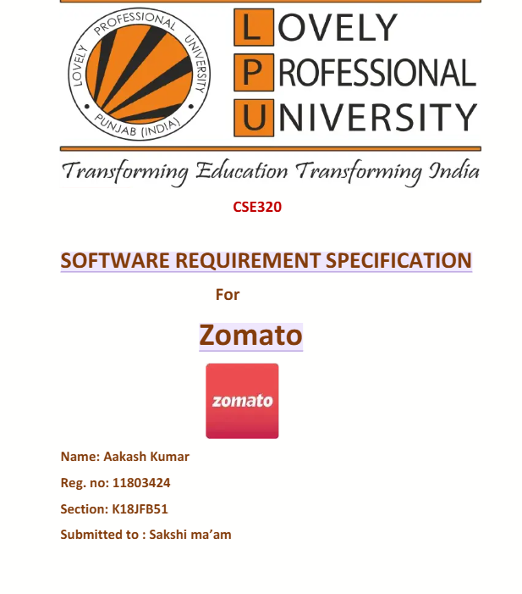
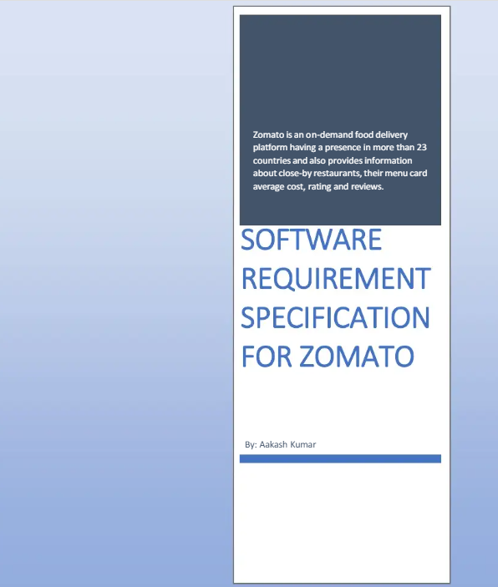
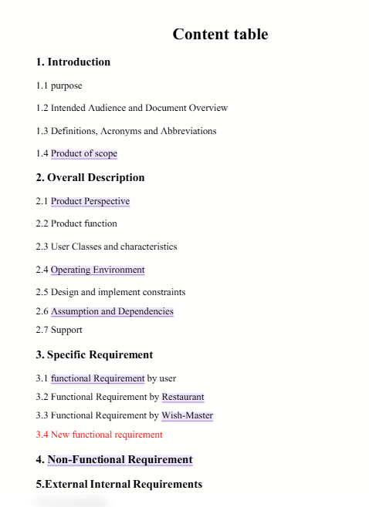
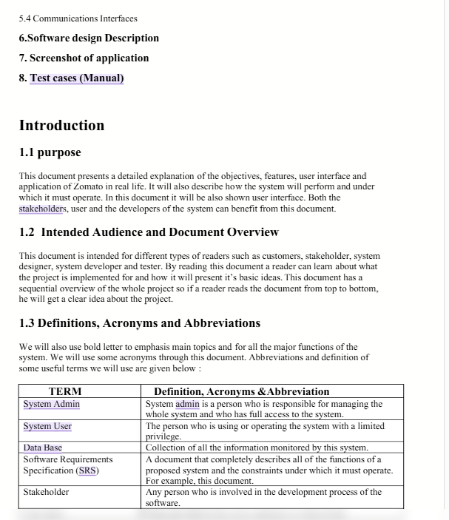
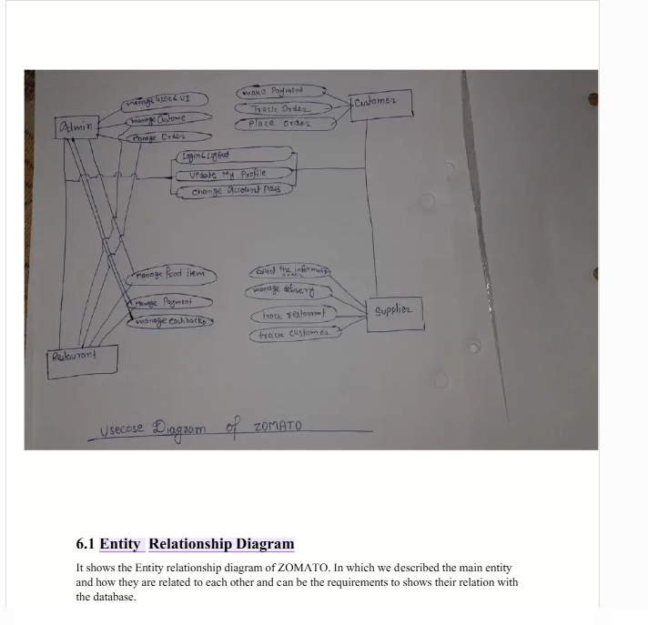
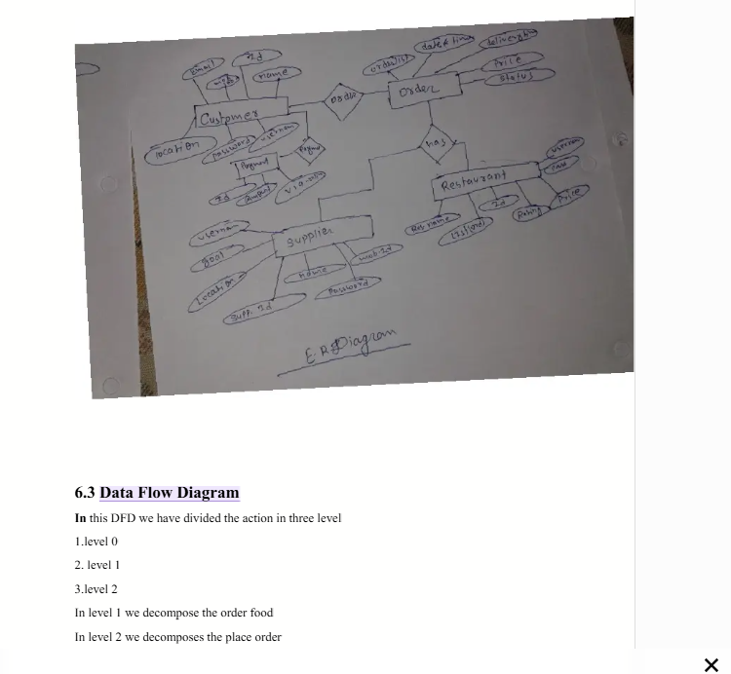
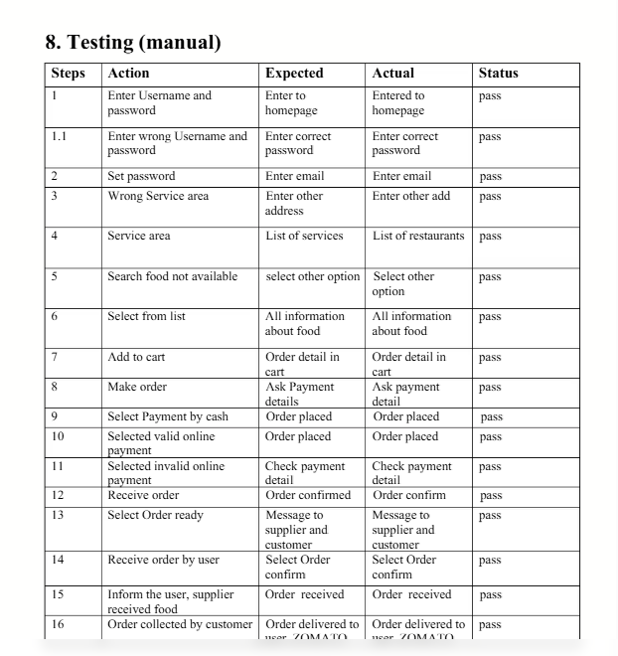

unclear or ambiguous requirements=
- The system should show nearby restaurants.
- The application should be user-friendly.
- The system should provide fast search results.
- Users can cancel their orders.
- The application should work on different devices

- Conduct an informal review of a friend's written test case set for a simple login feature (username and password), and write down 3 suggestions or improvements you would make. as a manual tester
Ans=>
- Add positive and negative test cases
- Verify login with valid username + valid password.
- Also test invalid username, invalid password, both invalid, and blank username/password.
- This helps ensure the system handles incorrect inputs properly.
- Include boundary and input-validation testing
- Test minimum and maximum allowed username/password lengths.
- Try spaces, special characters, and very long inputs.
- Check whether appropriate validation/error messages are displayed.
- Add usability and security checks
- Verify the password is masked while typing.
- Check that error messages are clear and do not reveal sensitive information.
- Test whether the Login button behaves correctly when fields are empty or after multiple failed attempts.

3. Simulate a walkthrough session by explaining the steps of a test case for 'Add to Cart' functionality (like Flipkart) to a classmate and note any questions or feedback they give you.<br><br><em><strong>Hint:</strong> Focus on whether all steps are clear and if any preconditions or expected results are missing.</em>
Ans=>
Test case= Verify that a user can add a product to the cart.
Steps =
1 Open the Flipkart-like shopping website.
2 Log in with a valid user account.
3 Search for a product, such as “Bluetooth headphones.”
4 Select a product from the search results.
5 Open the product details page.
6 Click the “Add to Cart” button.
7 Open the shopping cart.
  - Question: What should be mentioned as a precondition?
Ans: Add that the user should have a valid account and should be logged in before starting the test.

- Identify 4 types of errors or issues that static testing (reviewing documents or code without execution) can catch in a test case document for an online movie booking system (like BookMyShow).
Ans=>
  - Important steps may be missing, such as selecting the movie, theatre, showtime, and seats before making payment.
  - The expected result may not match the action. For example, after selecting seats, the test case should state that the selected seats are shown as reserved/selected.
  - The test case may not mention requirements such as having a valid user account, selecting a movie with available shows, or having available seats.
  - The document may only test successful booking and not cover cases such as unavailable seats, failed payment, invalid coupon codes, or selecting a past showtime.

